INDIVIDUAL VULNERABILITY DIFFERENCES ON FEAR LEARNING AND THEIR RESPONSE TO EXTINCTION AND RENEWAL PROCESS

Gustavo Munroª, Luis Pardoª, Vanetza Quezada-Scholz^{a*}, Bram Vervliet^{b}, Mario Labordaª, Gonzalo Miguezª, Consuelo San Martin^{c}
ªDepartamento de Psicología, Facultad de Ciencias Sociales, Universidad de Chile
^{b}Center for Excellence on Generalization in Health and Psychopathology, KU Leuven University, Leuven, Belgium
^{c}Escuela de Psicología, Universidad de los Andes, Santiago, Chile

*Corresponding Author: Vanetza Quezada-Scholz, qvanetza@u.uchile.cl

This work was supported by the Agencia Nacional de investigación y Desarrollo (ANID) [FODENCYT de Iniciación #11170143]

Abstract
Introduction: Individual Vulnerabilities Differences (IVD) affect fear learning and expression in the development of anxiety disorders. However, there is scarce information about their role in relapses after extinction. Objectives: To evaluate the relationship between state (STAI-S) and trait anxiety (STAI-T), intolerance to uncertainty (IUS) and depression (BDI), with fear acquisition, extinction, and renewal in 93 adults. Method: In the acquisition (context A), different colored lights followed by an aversive image (US) were presented as conditioned stimuli (CS). During the extinction, the CS were presented without EI in context B. The renewal occurred in a new context C. Responses were assessed by US Expectancy Ratings and CS Anxiety Ratings. Results: Both expectancy and anxiety responses decreased during extinction while expectancy reappeared during renewal. Furthermore, higher BDI scores were related to higher expectancy during extinction and renewal, while higher BDI and STAI-T scores were associated with higher anxiety during extinction and renewal. Additionally, higher values on IUS were linked with increased anxiety during acquisition. Discussion: Subjects with a higher score in certain IVD will present a stronger and more resilient fear response to aversive stimuli. Thus, the relationship between IDV and the treatment of anxiety disorders should be studied for clinical development.
Key words: experimental psychopathology, anxiety disorders, exposure therapy, tolerance to uncertainty, depression

Resumen
Introducción: Las diferencias individuales de vulnerabilidad (DIV) afectan el aprendizaje y expresión del miedo en el desarrollo de los trastornos de ansiedad (TA). Sin embargo, hay escasa información sobre su rol en las recaídas tras la extinción. Objetivos: Se evaluó la relación entre estado (STAI-S) y rasgo ansioso (STAI-T), intolerancia a la incertidumbre (IUS) y depresión (BDI), con la adquisición, extinción y renovación del miedo en 93 adultos. Metodología: En la adquisición (contexto A), se presentaron como estímulos condicionados (EC) luces de diferentes colores seguidos de una imagen aversiva (EI). Durante la extinción los EC se presentaron sin EI en un contexto B, mientras que la renovación ocurrió en un nuevo contexto C. Se evaluó la respuesta de miedo mediante la expectativa de ocurrencia del EI y la ansiedad percibida ante los EC. Resultados: Se observó que las respuestas de expectativa y ansiedad disminuyeron durante la extinción, mientras que la expectativa reapareció durante la renovación. Además, mayores puntajes en BDI se relacionaron con mayor expectativa durante la extinción y renovación, mientras que mayores puntajes en BDI y STAI-T se asociaron con mayor ansiedad durante la extinción y renovación. Adicionalmente, valores más altos en IUS se vincularon con más ansiedad durante la adquisición. Discusión: Aquellos sujetos que presenten mayores puntajes en determinados DIV presentarán una respuesta de expectativa y ansiedad mayor ante estímulos aversivos. Se debe estudiar clínicamente la relación de las DIV y el tratamiento de los TA para el desarrollo de terapias más eficaces y duraderas.
Palabras claves: psicopatología experimental, trastornos de ansiedad, terapía de exposición, tolerancia a la incertidumbre, depresión
Introduction
Fear and anxiety are natural adaptive responses present in most living beings to cope or respond against different threats. Nonetheless, when fear or anxiety is generalized to common non-threatening day to day situations it becomes pathological, severely impacting people’s quality of life. In other words, pathological fear has a slower decrease overtime, it persists even when the threatening stimuli are not present, and it is usually associated with a stronger response towards the aversive stimuli when presented or signaled (Andreatta et al. 2015; Davis et al., 2010; Domjan, 2014; Duits et al., 2015; Hamm and Weike, 2005; Lipp et al., 1994; Pavlov, 1927; Rescorla, 1988).
In addition, fear and anxiety-related disorders like the Generalized Anxiety Disorder (GAD), Post Traumatic Stress Disorder (PTSD), or phobias (e.g social phobia) have a high prevalence in today's world, and they are one of the most studied phenomena in clinical psychology. But despite years of research and clinical testing, fear and anxiety-based disorders are still on the rise (Arrieta-Vergara et al., 2014; Bandelow and Michaelis, 2015; Campo-Arias and Cassiani, 2008; Lissek et al., 2005; Lonsdorf et al., 2017; Olatunji et al., 2007). For example, in Chile, according to the Chilean Ministry of Health (MINSAL, 2018), at least 16% of the population over 15 years old had been affected by one or more fear or anxiety-based disorders. Highlighting the importance to continue research in this area and be able to provide more accessible and efficient treatments (Araya et al. 2001; Bandelow & Michaelis, 2015; Barrera-Herrera & San Martín, 2021; Lonsdorf et al., 2017; Vicente, 2002; Vicente et al., 2016).
However, first it is necessary to understand the etiological mechanism of fear and anxiety-based disorders to comprehend their current treatment and state of the art in psychology. Hence it is important to talk about Pavlovian Conditioning (also known as Classical Conditioning). In other words, fear and anxiety-relat ed disorders have their roots in the fear learning paradigm, where a novel innocuous stimulus, also known as neutral stimulus (NS), which does not evoke any response from a complex living being, links with another stimulus, which has a biological relevance and thus it does provoke a physical or psychological response (also known as unconditioned stimulus or US) – the response triggered by the US is known as unconditioned response (UR) –. This association turns the NS into a conditioned stimulus (CS) being able to produce the same or almost the same UR as the US (also known as conditioned response or CR). Therefore, a previously innocuous stimulus is now able to evoke a strong fear or anxiety response whenever it is presented or signaled. Additionally, this CS could also be generalized to similar stimuli and to the context in which it occurs. This is highly problematic when talking about fear and anxiety-based disorders since pathological fear could link necessary daily tasks (e.g speaking in public) to a strong aversive response, making the subject avoid said task and thus hindering its quality of life. (Bouton et al., 2006; Bouton, 1993, 2004; Bouton & King, 1983; Grillon, 2008; Laborda et al., 2012; Laborda & Miller, 2013; Liao & Craske, 2013).
The above explains how a NS is able to transform to CS through its linking with an US, but the response towards this association can also be detrained and thus reduced. This process is known as extinction and it is the mechanical basis for exposure therapies, which are the way to go in psychology regarding evidenced based treatments for fear and anxiety disorders like GAD, PTSD, or phobias (Craske et al., 1991; Craske et al., 2014; Craske, 2015; Lissek et al., 2005). Extinction happens when a determined CS is repetitively presented without its corresponding US, thus retraining its related CR. This produces a diminishing of the subject’s response towards said CS, or in other words, the person learns that the feared stimulus will not produce its dreaded consequences or that it is safe (Lohr et al., 2007; Seligman & Binik, 1971; Wolpe, 1958). Nonetheless, as it was hinted, extinction is not a complete erasure of the previously trained response, and thus its previous association could reappear after the extinction process. This resurgence shows the main problem in extinction-based therapies like the exposure technique, and hence in spite of their proven effectiveness, the return of the fear response after treatment (also known as relapse) may still occur. Highlighting the importance of further research regarding the etiological mechanism of fear and anxiety-based disorders (Craske et al., 1991; Craske et al., 2014; Craske, 2015; Lissek et al., 2005; Mineka & Zinbarg, 2006; Quezada-Scholz et al., 2018; Vervliet et al., 2013).
Now, there are three known reasons which explain relapse after treatment, the reestablishment of the contingency between CS and US (i.e reinstatement), a change to the context in which the response was extinguished (i.e renewal), or simply by the passing of time after treatment (i.e spontaneous recovery) (Bouton et al., 2006; Domjan, 2014; Haaker et al., 2015; Laborda et al., 2014). Many different techniques have been used over the years to maximize the extinction and prevent relapse, but further research is still needed, especially considering the prevalence of fear and anxiety-related disorders (Barlow et al., 2013; Craske et al., 2014; Diaz et al., 2017; Garcia-Palacios et al., 2007; Laborda & Miller, 2013; Lonsdorf et al., 2017; Olatunji et al., 2007; Vervliet et al., 2013).
Among the new findings in this field, the further insight related to Individual Vulnerabilities Differences (IVD) on fear learning paradigms have proven to be an important factor to consider when maximizing the effect of extinction, and thus improving the effect of exposure therapies (Duits et al., 2015; Flores et al., 2018; Haaker et al., 2015; Mineka & Sutton, 2006; Mineka & Zinbarg, 2006; Quezada-Scholz et al., 2019). Yet again there is still little data on how these findings relate or may affect relapse, especially renewal (Becker et al., 2013; Diaz et al., 2017; Haaker et al., 2015; Flores et al., 2018; Glotzbach-Schoon et al., 2015; Grillon et al., 2009; Lonsdorf & Merz, 2017; Quezada-Scholz et al., 2019; Torrents-Rodas, 2013; Vervliet et al., 2013). Therefore, expanding into this area may yield a promising breakthrough to understand the underlying mechanisms in the acquisition, expression, extinction, and relapse of fear, leading to the development of better cost-effective therapies (Duits et al., 2015; Dunsmoor et al., 2015; Dymond et al., 2015; Scheveneels et al., 2016, 2021).
As for the IDV, these can be interpreted as the combination of previous experiences, temperament and personality, genetics, or any biopsychosocial factor that is able to influence the degree in which a certain stimulus or situations are perceived as threatening (Boddez et al., 2012; Duits et al., 2015; Gazendam et al., 2013; Mineka & Sutton, 2006; Mineka & Zinbarg, 2006; Lissek et al., 2005, 2006, 2009, 2010). And consequently, increasing or decreasing the fear response, varying the outcome of different individuals against the same conditions, which has profound implications in the fear learning paradigm, specially over the extinction and relapse mechanism (Dymond et al., 2015; Haaker et al., 2015; Scheveneels et al., 2016, 2021).
As example, a study conducted by Greshman and Hartley (2015) found a high variability between individuals and the return of the fear response in a classical fear conditioning paradigm. Specifically, different subject’s qualitative properties (i.e IDV) were associated to differences in consolidation of extinction memory, thus making some individual more likely to relapse in the future. Said hypothesized differences had a clear biological impact but they were not further analyzed by that study.
On the other hand, an exhaustive review by Lonsdorf and Merz (2017) analyzed the importance of different IDV classical fear conditioning paradigm and the return of fear. Nonetheless, despite completing the previously mentioned findings and consolidating the importance and effect of IDV over different biological and psychological mechanisms in fear learning and its renewal, evidence is still contradictory and insufficient. Further encouraging the need to expand and interdisciplinary knowledge in this area, considering its relevance for the future of clinical interventions.
Now as it was mentioned above, there are many different factors which may act as IDV (Becker et al., 2013; Boddez et al., 2012; Haaker et al., 2015; Glotzbach-Schoon et al., 2015; Lonsdorf & Merz, 2017; Moreno et al., 2016; Quezada-Scholz et al., 2019). But to provide exhaustive work about them is beyond the scope of the present research and the interest to focus their impact over a classical fear learning paradigm, especially regarding the renewal phenomenon, since it is still not so well studied.
For these reasons, previously known IDV indicators already documented in the current literature will be used in the present study (Lonsdorf & Merz, 2017; Quezada-Scholz et al., 2019; Torrents-Rodas, 2013). Specifically, the Intolerance to Uncertainty Scale (IUS; Freeston et al., 1994), the State-Trait Anxiety Inventory (STAI; Spielberger et al., 1986) and Beck’s Depression Inventory (BDI; Beck et al., 1961) as main IDV indicators.
Hence, the present study will examine the relationship between determined IDV indicators over the acquisition, extinction, and renewal of fear in a classical conditioning paradigm. Concretely, we expect that individuals who attained higher scores in any IDV indicator questionnaires will show a stronger fear response towards stimuli (i.e CS) which were previously signaled by an upcoming aversive stimulus (i.e US) during the acquisition and extinction process. While they will also have an increased behavioral and emotional relapse of the fear response during the renewal phase. And lastly, we expect these individuals to have a likewise increased response towards a filler cue during the acquisition process.

Method
To assess the objectives of the present study, a within-subject experiment was implemented (see Figures 1-3). Due to complications derived from the COVID-19 pandemic we opted to utilize online platforms for the experiment and its corresponding questionnaires.
The experimental task was developed using Python and the PsychoPy3 builder software (version v2020.2.3), and later uploaded to Pavlovia online platform for its implementation, while all the questionnaires were uploaded to Survey Monkey. The participants only gained access to the experimental task after answering all the aforementioned questionnaires.
Participants
A total of 93 participants over 18 years old took part and completed the experiment. All subjects had to agree to an informed consent approved by the Universidad de Chile’s Ethics Committee of Research in Social Sciences before both the questionnaires and the experiment.
Conditioned and Unconditioned Stimuli
As CS we used the light emitted by the desk’s lamp, each CS had a different light color. Green and Yellow were counterbalanced as CS+ while Red was always a CS- (i.e filler cue). On the other hand, the International Affective Picture System (IAPS) (Lang et al., 2008) was utilized as US. Specifically, the attack dog (IAPS image #1525) and masked man (IAPS image # 6370) images were used because they were identified as fear evoking pictures by Moreno et al. (2016).
Experimental contexts
For the different contexts through the experiment the image of a room with a lamp on a desk was used. Each context varied in the color of the wall and the image in the frame that was placed next and above the desk. Context was counterbalanced during the extinction and renewal phase.
Measurements
The behavioral fear response was measured using the occurrence expectancy to fear evoking picture (US Expectancy Ratings) and the emotional fear response was determined by the Anxiety Ratings towards each CS. Different online visual analog scales (VAS) were implemented to each corresponding measurement. The US Expectancy Ratings (E-VAS) was assessed during the presentation of each CS with a VAS from 1 to 100, where 1 was highly unlikely for a fear evoking picture (US) to appear after the presentation of the CS and 100 was very likely for a US to appear after the presentation of the CS. And the Anxiety Ratings to each CS (A-VAS) was measured after each experimental phase by a 1 to 100 VAS presented after each CS, where 1 was non anxious, and 100 was highly anxious.
To measure the IVD indicators between subjects we utilized the corresponding Chilean (or Latin American) validated questionnaires for State-Trait Anxiety Inventory (STAI-S/T) (Vera-Villarroel, 2007), the Intolerance of Uncertainty Scale (IUS) (Rodríguez de Behrends & Brenlla, 2015) and Beck’s Depression Inventory (BDI) (Valdés et al., 2017). All these scales were applied through the online platform Survey Monkey prior to the experiment.
In addition, after all the experimental phases, participants were asked their aversiveness towards each US in a 1 to 100 VAS, where 1 was not aversive and 100 was highly aversive. And lastly, they were also asked about the anxiety they felt during the experiment in another 1 to 100 VAS, where 1 was non anxious and 100 was highly anxious.
Procedure
The experiment was divided into three sections, an acquisition phase, an extinction phase, and a renewal phase. In addition, there was a 4 second intertrial interval (ITI), all CS lasted for 8 seconds, and all US were presented for 2 seconds.
Acquisition
The acquisition (see Figure 1) consisted of 6 trials in which the CS+ (green and yellow light) were followed by their corresponding US (IAPS’s attack dog and masked man), while the filler cue (CS-) (red light) did not signal an upcoming US. The E-VAS was shown during the duration of each CS. After this phase all the CS presented were shown again one additional time, each of them was followed by the A-VAS.

Figure 1
Acquisition Phase (Context A)
6xCS | US
 | 
 | 

Note. Acquisition Phase’s experimental design in context A. The context consists of a desk table, a lamp, and a determined framed picture. All CS are the color of the light shown by the lamp (i.e yellow, green, and red). The CS+ are always green and yellow counterbalance with their respective US, and the CS- (filler cue) is always red. All CS were shown 6 times for 8 seconds along with the E-VAS. The ITI was 4 seconds. The A-VAS was presented after the 6 trials.

Extinction
The extinction (See figure 2) phase lasted 10 trials in which the CS+ presented in the acquisition phase were not followed by their corresponding US. The filler cue did not appear during this phase. And just like in the acquisition, the E-VAS was shown during the duration of each CS. After this phase all the CS were presented one more time along with the A-VAS.
Figure 2
Extinction Phase (Context B)
10 xCS | US


Note. Extinction Phase’s experimental design in context B. The context consists of a desk table, a lamp, and a determined framed picture. All EC are the color of the light shown by the lamp (i.e yellow and green). The CS- is no longer present after this phase. All CS were shown 10 times for 8 seconds along with the E-VAS. The ITI was 4 seconds. The A-VAS was presented after the 10 trials.

Renewal
The renewal (See figure 3) phase only consisted of one trial, in which the extinguished CS+ were shown again in their extinction context and then shown in a novel context to its respective stimulus. The E-VAS was presented along with the CS, and the A-VAS was asked for each CS after the trial.
Figure 3
Renewal Phase
Extinction Test (Context B) |  | Renewal Test (Context C)
1xCS | US | 1xCS | US
 |  | 
 |  | 
Note. Renewal Phase’s experimental design in context B and C. The context consists of a desk table, a lamp, and a determined framed picture. All EC are the color of the light shown by the lamp (i.e yellow and green). The order of the tests was random, their CS and respective context were shown one time for 8 seconds along with the E-VAS. The ITI was 4 seconds. The A-VAS was presented after the only trial of both tests.

Exclusion criteria and data analysis
Psychological Criterion
To preventively assessed if the participants were in adequate psychological health conditions to participate in the experiment, they were measured with the Chilean validated Symptom Checklist-90 (SCL90; Derogatis, 1992; Gempp-Fuentealba and Avedaño-Bravo, 2008), only low risk individuals were eligible, but none of them were excluded by this criterion.
Learning Criterion
To ensure participants successfully learned the experimental task (i.e they were responding to a classical fear conditioning paradigm), the following exclusion criteria was used: a) any subject who missed three or more responses was eliminated from the experiment; b) any subject who responded with 35 or more points to the E-VAS corresponding to CS- (i.e filler cue) during the last two trials of the acquisition was ruled out; or c) any subject who responded with 75 or less points to the E-VAS corresponding to any of the CS+ during the last two trials of the acquisition was also excluded.
Only 44 out of the initial 93 participants were considered for the analysis after the application of this criterion.
Finally, data was analyzed using TIBCO’s STATS 12 software, while the graphics were constructed by using GraphPad’s Prism 9 software.
Results
A total of 44 (20 females) out of the initial 93 subjects were considered in the experiment. Descriptive data is reported but no further analyzed. The mean age among the participants was 27.39 years old (SD = 10.17, n = 44), a total of 25 subjects were students (56.82%), 14 of them were employed (31.82%), and 3 of them were either retired, unemployed or looking for work (6.82%). Lastly, two of the subjects were reported as missing descriptive data from now on, but they were considered during the experiment.
Regarding the SCL90, 18 (40.91%) out of 42 participants reported to have been clinically diagnosed with one or more mental disorders at least once in their lifetime. Where 13 of them reported to have been diagnosed with one disorder (29.55%), 4 of them reported to have been diagnosed with two disorders (9.09%), and 1 of them reported to have been diagnosed with three clinically diagnosed disorders (2.27%). Among these, 7 were depression related disorders (15.91%), 6 were anxiety related disorders (13.64%), 2 were attention deficit disorder (4.55%), 1 was a personality related disorder (2.27%), 2 were sleep disorders (4.55%), and 6 were classified as other disorders by the SCL90 (13.64%). No addiction or bipolar related disorders were found. In addition, 9 of the participants reported to be under ongoing psychological treatment (20.45%), where 8 of them reported to currently have a mental disorder (18.18%).
Blocks and corresponding phases analysis
The trials of each experimental phase were collapsed into blocks of two, using the corresponding means for the analysis. In other words, the acquisition phase had six trials, thus it was divided into three blocks, while the extinction phase had ten trials, thus it was divided into five blocks. For the renewal phase, its data was obtained by the comparison between the extinction and renewal test present in said phase.
US Expectancy Ratings (E-VAS)
Acquisition
A repeated measurement ANOVA was used using the stimuli (both CS+ and CS-) as a within subject factor. Differential conditioning was successful (Fig. 4) as demonstrate by the following main interaction between the stimuli and their respective block (F (3.59,150.64) = 119.53, p < .01, MSE = 260, ƞ²p = .74, IC 95% [0.68, 1.00]), and by the comparison of both CS+ (i.e attack dog and masked man) against the CS- during the first and last block of the acquisition (F( 1,42) = 309.12, p < .01, MSE = 353.4, ƞ²p = .88, IC 95% [0.82, 1.00]). In addition, the effect of the blocks and stimuli by themselves was also significant (F (1.92,80.54) = 27.57, p < .01, MSE = 281, ƞ²p = .40, IC 95% [0.26, 1.00] and F (1.81,75.98) = 230.33, p < .01, MSE = 466, ƞ²p = .85, IC 95% [0.80, 1.00] respectively).

Figure 4
Mean US Expectancy Ratings towards each CS per trial block during acquisition phase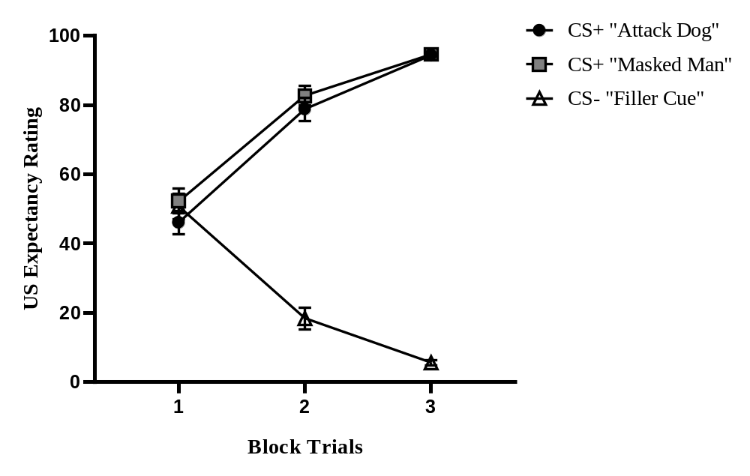Note. The graphic represents the mean expectancy response toward the CS during the acquisition phase. A differential learning between the CS+ and the CS- can be observed during blocks 2 and 3.

Extinction
A repeated measurement ANOVA was used for this analysis, using both stimuli (CS+) as a within subject factor. Extinction was successful (Fig. 5) due to the lack of main effect in both the interaction between blocks and stimulus (F (4,156) = 1.45, p = .219003, MSE = 70, ƞ²p = .04, IC 95% [0.00, 1.00]) and the effect of the stimuli by themselves (F (1,39) = .57, p = .455787, MSE = 155.4, ƞ²p = .01, IC 95% [0.00, 1.00]). As well a main effect by the blocks over the response over time was found (F (2.30,89.89) = 93.60, p < .01, MSE = 343.7, ƞ²p = .71, IC 95% [0.62, 1.00]).
Figure 5
Mean US Expectancy Ratings towards each CS per trial block during extinction phase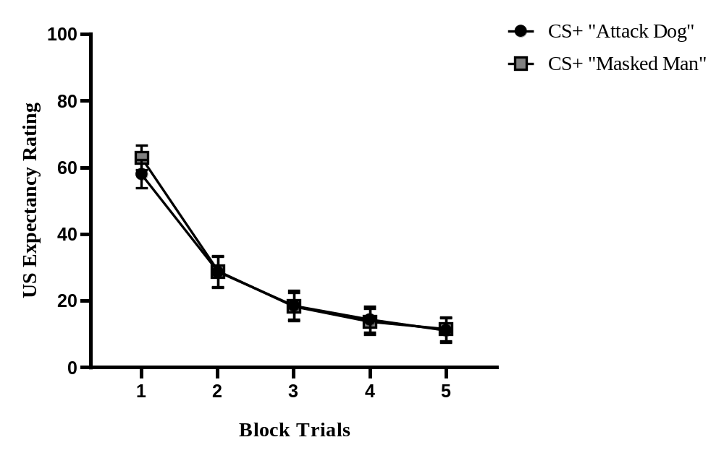Note. The graphic shows the mean expectancy response towards the CS during the extinction phase. A decrease in the response over time can be observed with no further difference between either CS.

Renewal
To analyze the renewal response, the extinction and renewal test were matched against each other. Thus, a repeated measurement ANOVA was utilized for this analysis using the stimuli (CS+) as a within subject factor. Renewal relapse was successfully found (Fig. 6) by the main effect of the comparison between both tests (F (1,39) = 4.95, p < .01, MSE = 262.6, ƞ²p = .11, IC 95% [0.01, 1.00]). Additionally, there was not a significant interaction between both stimulus and test (F (1,39) = .01, p = .916646, MSE = 299.5, ƞ²p = .00, IC 95% [0.00, 1.00]), and there was also not a significant effect by the stimulus by themselves (F (1,39) = 1.26, p = .267980, MSE = 185.3, ƞ²p = .03, IC 95% [0.00, 1.00]).
Figure 6
Mean US Expectancy Ratings towards each CS per trial block during renewal phase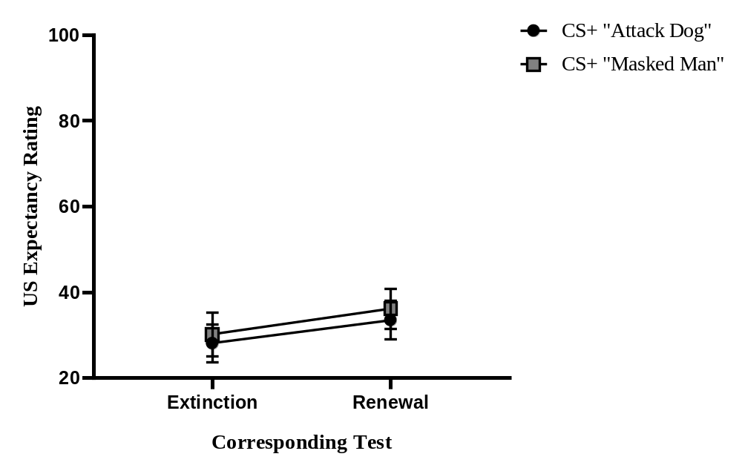Note. The graphic demonstrates the mean expectancy response between the extinction and renewal test presented during the renewal phase. There is a significantly greater response to both CS+ in the renewal test.

Anxiety Ratings (A-VAS)
Acquisition
A repeated measurement ANOVA with the stimuli used as a within subject factor was utilized for this analysis. There were not significative differences in the Anxiety Ratings between the stimuli (F (1.71,73.70) = 2.90, p = .060287, MSE = 473, ƞ²p = .06, IC 95% [0.00, 1.00]). In addition, a significative difference when comparing both CS+ against the CS- was not found (Fig. 7) (F (1,43) = 3.94, p = .053613, MSE = 687.75, ƞ²p = .08, IC 95% [0.00, 1.00]). In other words, the anxiety response was similar regardless of the stimuli during the acquisition.
Figure 7
Mean Anxiety Ratings towards each CS after the acquisition phase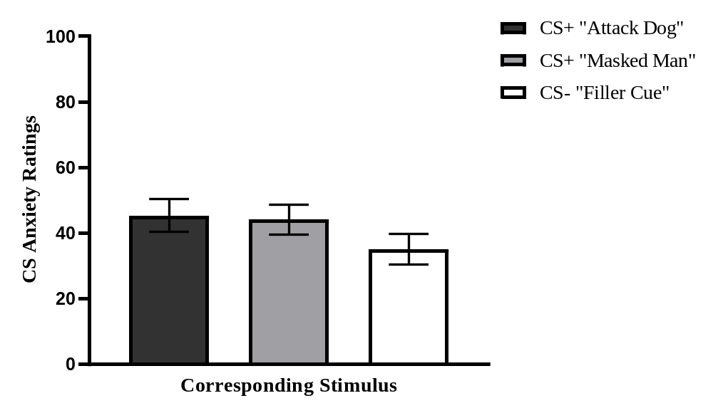Note. The graphic indicates the mean emotional anxiety response to all the CS after the acquisition phase. There is significantly more anxiety reported towards the CS+ than the CS-.

Extinction and Renewal
To evaluate anxiety during extinction and the renewal, only the answers during the extinction and renewal test were considered due to the intention of comparing both phenomena. To further increase the scope and validity of the analysis, these answers were also matched against the ones obtained from acquisition phase. Thus, repeated measurement ANOVA was conducted using the stimuli as a within subject factor. Furthermore, due to the aforementioned, the CS- was not included in this analysis. A main effect interaction regarding the respective phenomenon evaluated and its reported anxiety was found (Fig. 8) (F (1.27,53.46) = 28.79, p < .01, MSE = 597.8, ƞ2p = .41, IC 95% [0.24, 1.00]). Additionally, significant differences were found when comparing the anxiety reported during the acquisition versus the anxiety reported during the extinction test, being the former greater than the latter (F (1,42) = 36.65, p < .01, MSE = 780.92, ƞ²p = .47, IC 95% [0.28, 1.00]). Nonetheless, there was no significant interaction when matching the anxiety reported during the extinction test versus the anxiety reported during the renewal test (F (1,42) = 2.35, p = .132893, MSE = 148.55, ƞ²p = .05, IC 95% [0.00, 1.00]). Finally, no main effect interaction was found when either comparing the stimuli by themselves or when analyzing the interaction between stimuli and phenomena (F (1,42) = .21, p = .647133, MSE = 227, ƞ²p = .01, IC 95% [0.00, 1.00] and F (2,84) = .18, p = .839066, MSE = 122.7, ƞ²p = .00, IC 95% [0.00, 1.00]).

Figure 8
Mean Anxiety Ratings towards each CS+ during extinction and renewal test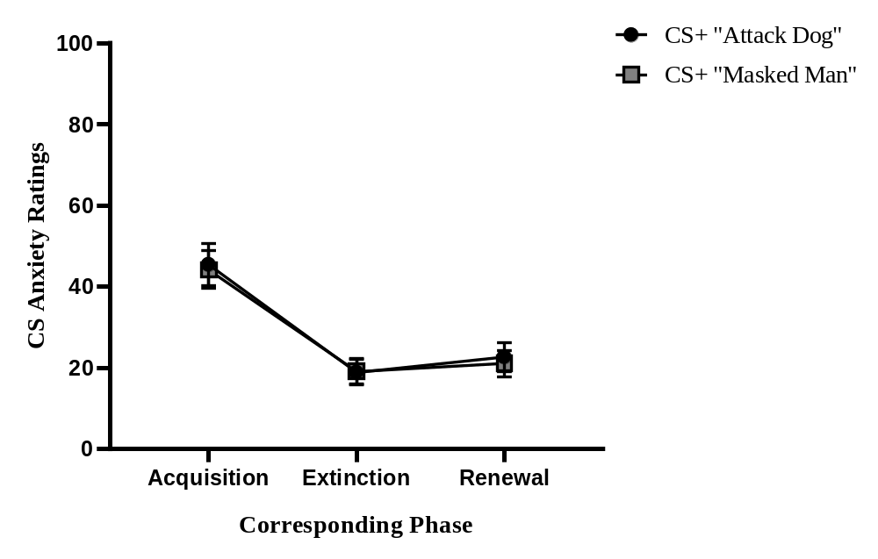Note. The graphic shows the mean emotional anxiety response during the different phases. There is a significant difference between acquisition and extinction, and between extinction and renewal. All A-VAS were presented to the subjects after their respective phases.

Aversiveness towards the US and overall anxiety
After the final phase of the experiment, participants reported an overall aversiveness towards the attack dog image of 70.72 (SD = 28.45, n = 44) and towards the masked man image of 56.45 (SD = 31.47, n = 44). There was a significant difference between both stimuli (Z = 2.78, p < .01, r = .43), showing that the attack dog evoked greater levels of aversiveness over the masked man image. And lastly, participants reported an overall 43.59 (SD = 26.39, n = 44) points in the anxiety felt during the duration of the whole experiment showing mild to low levels of anxiety based on the 1 to 100 VAS, where 1 was non anxious and 100 highly anxious.
IVD Correlations
To evaluate the correlation between the IVD and the behavioral responses we utilized Kendall’s Tau-b due to the absence of normality as recommended in Croux and Dehon (2010). In addition, we only consider the acquisition’s last block trials and the extinction and renewal test from the renewal phase for the data analysis.
Expectancy (E-VAS)
Significant correlations using Kendall’s Tau-b between the IVD indicators (i.e prior questionnaires) and the fear expectancy towards the stimuli (as shown in Table 1) were found. In detail, one of the IDV indicators, Beck’s Depression Inventory showed a direct relationship with the behavioral fear response during the CS+ extinction and renewal tests. In other words, the greater the BDI score the greater the fear expectancy towards the CS+ during the extinction and renewal. Nonetheless, a significant correlation between any of the IDV indicators and the fear expectancy during the acquisition phase was not found.

Table 1
IDV Indicators and US fear expectancy towards the CS
IDV Indicator | CS+ Last Acquisition Block | CS- Last Acquisition Block | CS+ Extinction Test | CS+ Renewal Test
STAI-S | .06 | .-02 | .10 | .12
STAI-T | .04 | .01 | .08 | .12
BDI | .01 | .10 | .15* | .15*
IUS | .06 | .01 | .01 | .06
Note. The present table shows Kendall’s Tau-b values between the different IDV and the behavior fear response (E-VAS) towards the stimuli. A significant correlation was found between the BDI scores and the fear expectancy towards the stimuli during the extinction and renewal test. The STAI-S corresponds to the State-Trait Anxiety Inventory’s State subscale, while the STAI-T corresponds to the State-Trait Anxiety Inventory’s Trait subscale, the BDI corresponds to Beck’s Depression Inventory, and the IUS corresponds to the Intolerance to Uncertainty Scale. * p < .05

Anxiety (A-VAS)
Significative correlations were found relating to some IDV indicators and the anxiety felt towards the CS+ (as shown in Table 2). Specifically, there was an increase in the anxiety felt towards the CS+ during the acquisition phase in participants who scored higher on the IUS questionnaire. While on the other hand, there was an increased report in the anxiety felt towards the CS+ during the extinction and renewal test in subjects who had higher STAI-T and BDI questionnaire scores.
Table 2
IDV Indicators and Anxiety Ratings towards the CS
IDV Indicator | CS+ Last Acquisition Block | CS- Last Acquisition Block | CS+ Extinction Test | CS+ Renewal Test
STAI-S | .11 | .09 | .11 | .13
STAI-T | .08 | .07 | .17* | .15*
BDI | .05 | .10 | .20* | .16*
IUS | .18* | .14 | .012 | .13
Note. The table indicates Kendall’s Tau-b values between the different IDV and the emotional fear response (A-VAS) towards the CS. Significant correlations were found during acquisition, extinction, and renewal. The STAI-S corresponds to the State-Trait Anxiety Inventory’s State subscale, while the STAI-T corresponds to the State-Trait Anxiety Inventory’s Trait subscale, the BDI corresponds to Beck’s Depression Inventory, and the IUS corresponds to the Intolerance to Uncertainty Scale. * p < .05

IDV Correlations between overall anxiety and US aversiveness
The correlation data analysis showed one significant link between the IUS score and the anxiety felt during the whole experiment (as shown in Table 3). In addition, the STAI-T and the IUS questionnaires were significantly matched with increased anxiety felt towards the masked man image. Despite the attack dog image having significantly greater evoked anxiety than the masked man image, no correlation was found between the former and any of the IDV indicators.
Table 3
IDV Indicators, overall anxiety and US aversiveness
IDV Indicator | CS+ “Attack Dog” | CS+ “Masked Man” | Overall Anxiety
STAI-S | .11 | .08 | .07
STAI-T | .07 | .23* | .18
BDI | .03 | .12 | .12
IUS | .14 | .35* | .28*
Note. The table indicates Kendall’s Tau-b values between the different IDV and the level of aversiveness towards each US and the overall anxiety felt through the experiment. Significant correlations were found regarding the overall anxiety reported during the experiment. The STAI-S corresponds to the State-Trait Anxiety Inventory’s State subscale, while the STAI-T corresponds to the State-Trait Anxiety Inventory’s Trait subscale, the BDI corresponds to Beck’s Depression Inventory, and the IUS corresponds to the Intolerance to Uncertainty Scale. * p < .05

Discussion
The present findings indicate a differential learning (e.i increased responses toward the CS+ in contrast to the CS-) during the acquisition, a decrease in both behavioral and emotional responses during the extinction, and the return of said responses in the renewal phase. In other words, a classical fear learning paradigm was achieved (Andreatta et al., 2015; Davis et al., 2010; Domjan, 2014; Duits et al., 2015; Hamm & Weike, 2005; Laborda et al., 2012; Lissek et al., 2005; Lohr et al., 2007; Mineka & Sutton, 2006; Mineka & Zinbarg, 2006; Pavlov, 1927; Seligman & Binik, 1971).
Now as it was expected, higher IDV scores influenced the perception of fear in individuals, showing increased behavioral and emotional towards the stimuli. In detail, subjects who obtained greater scores in the BDI scales had a greater fear expectancy towards previous aversive stimuli during the extinction and renewal test. While people who scored higher in the IUS questionnaire showed stronger perceived anxiety towards the aversive stimuli during the acquisition, whereas those who had larger STAI-T and BDI scores displayed a sturdier emotional response during the extinction and renewal test. In addition, the STAI-T and IUS indicator was linked to greater Anxiety Ratings towards the masked man image, and only the IUS scale predicted an increase in the overall anxiety felt by the participants throughout the whole experiment.
On the other hand, and contrary to Torrent-Rodas et al. findings (2013), a significant relationship between at least one IDV (i.e BDI) and the behavioral response towards fear expectancy was found in addition to the increased emotional response. Nonetheless, there were no differences between the perceived anxiety during the extinction and renewal test. This could be attributed to the robustness of the extinction process, but despite its effectiveness in reducing the subject’s emotional response, relapse still occurred regarding US Expectancy Ratings. This means, the BDI score could help to identify subjects in greater risk of relapse after treatment (Dibbets et al., 2015; Dibbets & Evers, 2017).
Furthermore, the present findings highlight the importance that different IDV may have over the fear learning and renewal paradigm. These qualitative and individual difference among subjects have multi and interdisciplinary implications in the treatment of anxiety disorders as it was previously hinted by older studies (Becker et al., 2013; Haaker et al., 2015; Greshman & Hartley, 2015; Flores et al., 2018; Lonsdorf & Merz, 2017; Quezada-Scholz et al., 2019). Especially considering some IDV may be related to neurological differences (Greshman & Hartley, 2015; Lonsdorf & Merz, 2017) which may impact the learning and renewal process.
This also supposes a shift in the way relapse, especially renewal, has been understood and studied by clinical psychology (Bouton et al., 2006; Domjan, 2014; Haaker et al., 2015; Laborda et al., 2014). Individual differences could have the same importance as the changes in the context, the contingency between stimuli or the passing of time. Thus, the IDV may be the key to improving one of the biggest struggles in clinical treatment and exposure therapy. In other words, further clinical research is needed to increase our understanding of these factors (Lonsdorf & Merz, 2017) and to provide stronger optimized and resilient therapies (Craske, 2015; Craske et al., 2014; Dymond et al., 2015; Laborda & Miller, 2013; Vervliet et al., 2013).
Finally, there were no observable differences regarding the perceived anxiety between both CS+ and the CS- during the acquisition process, meaning the anxiety perceived towards each CS was similar. Whereas the IUS scale was significantly linked only to the anxiety towards the CS+ during this phase, in addition to the overall anxiety felt throughout the whole experiment. This leaves the IUS questionnaire as a valuable indicator, as it screens subjects with a stronger emotional response towards fear. However, its etiological and clinical implications need to be further studied and analyzed. An additional suggestion is that the use of different IDV indicators as the ones used, or the use of a more immersive experimental situation (e.g virtual reality) may yield different results (Baas et al., 2004; Garcia-Palacios et al., 2007; Lonsdorf et al., 2017; Quezada-Scholz et al., 2022; Scheveneels et al., 2016, 2021).
It is also worth mentioning that the increased emotional reaction towards aversive stimuli as shown by the IUS scale could be further analyzed by the comparison between healthy and clinically anxious individuals. This could lead to an observable difference between the aversive stimuli and the filler cue during the acquisition because subjects with greater IUS scores are subject to greater fear and anxiety when learning a new aversive association. In addition, emotional differences between the extinction and renewal could also be expected when utilizing a clinical population. On the other hand, measuring the CS anxiety rantings before the acquisition could also provide further insight of the impact that IDV could have in clinically anxious individuals.
This is highly important to clinical settings since it may explain the link between individual differences and the resilience of some disorders due to a stronger emotional perception, this is a paramount element to be included in further development of new treatments and evidence-based psychology (Barlow et al., 2013; Beckers et al., 2013; Dunsmoor et al., 2015; Dymond et al., 2015; Lonsdorf et al., 2017; Scheveneels et al., 2016, 2021).
Finally, it needs to be noted that the present experiment was online only where all the measurements were made through a VAS. The implementation of a more natural in vivo experiment with the addition of physiological measurements (e.g galvanic skin conductance, startle reflex) may yield different results, which need to be further studied and compared (Garcia-Palacios et al., 2007; Greshman & Hartley, 2015; Lonsdorf & Merz, 2017; Quezada-Scholz et al., 2022).
In summary, the present study evidences the link between the behavioral and emotional response towards aversive stimuli and its links with different IVD, showing the importance of considering individual subject differences in further experiments. And as previous findings have already indicated it (Boddez et al., 2012; Flores et al., 2018; Greshman & Hartley, 2015; Gazendam et al., 2013; Glotzbach-Schoon et al., 2015; Haaker et al., 2015; Liao et al., 2013; Lonsdorf & Merz, 2017; Mineka & Sutton, 2006; Mineka & Zinbarg, 2006; Quezada-Scholz et al., 2019), it highlights the importance of the IDV as a major factor in the etiology of fear or anxiety-based disorders, and thus its relevance for clinical psychology and evidence base psychology.
References
Andreatta, M., Leombruni, E., Glotzbach-Schoon, E., Pauli, P., & Mühlberger, A. (2015). Generalization of contextual fear in humans. Behavior therapy, 46(5), 583-596. https://doi.org/10.1016/j.beth.2014.12.008
Araya, R., Rojas, G., Fritsch, R., Acuña, J., & Lewis, G. (2001). Common mental disorders in Santiago, Chile: prevalence and socio-demographic correlates. The British Journal of Psychiatry, 178(3), 228-233. https://doi.org/10.1192/bjp.178.3.228
Arrieta-Vergara, K. M., Díaz-Cárdenas, S., & González-Martínez, F. (2014). Síntomas de depresión y ansiedad en jóvenes universitarios: prevalencia y factores relacionados. Revista clínica de medicina de familia, 7(1), 14-22. https://doi.org/10.4321/S1699-695X2014000100003
Baas, J. M., Nugent, M., Lissek, S., Pine, D. S., & Grillon, C. (2004). Fear conditioning in virtual reality contexts: a new tool for the study of anxiety. Biological psychiatry, 55(11), 1056-1060. https://doi.org/10.1016/j.biopsych.2004.02.024
Bandelow, B., & Michaelis, S. (2022). Epidemiology of anxiety disorders in the 21st century. Dialogues in clinical neuroscience. 17(3), 327-335. https://doi.org/10.31887/DCNS.2015.17.3/bbandelow
Barlow, D. H., Bullis, J. R., Comer, J. S., & Ametaj, A. A. (2013). Evidence-based psychological treatments: An update and a way forward. Annual review of clinical psychology, 9, 1-27. https://doi.org/10.1146/annurev-clinpsy-050212-185629
Barrera-Herrera, A., & San Martín, Y. (2021). Prevalencia de Sintomatología de Salud Mental y Hábitos de Salud en una Muestra de Universitarios Chilenos. Psykhe (Santiago), 30(1), 1-16. https://doi.org/10.7764/psykhe.2019.21813
Beck, A. T., Ward, C. H., Mendelson, M., Mock, J., & Erbaugh, J. (1961). An inventory for measuring depression. Archives of general psychiatry, 4(6), 561-571. https://doi.org/10.1001/archpsyc.1961.01710120031004
Beckers, T., Krypotos, A. M., Boddez, Y., Effting, M., & Kindt, M. (2013). What's wrong with fear conditioning?. Biological psychology, 92(1), 90-96. https://doi.org/10.1016/j.biopsycho.2011.12.015
Boddez, Y., Vervliet, B., Baeyens, F., Lauwers, S., Hermans, D., & Beckers, T. (2012). Expectancy bias in a selective conditioning procedure: Trait anxiety increases the threat value of a blocked stimulus. Journal of behavior therapy and experimental psychiatry, 43(2), 832-837. https://doi.org/10.1016/j.jbtep.2011.11.005
Bouton, M. E. (1993). Context, time, and memory retrieval in the interference paradigms of Pavlovian learning. Psychological bulletin, 114(1), 80. https://doi.org/10.1037/0033-2909.114.1.80
Bouton, M. E. (2004). Context and behavioral processes in extinction. Learning & memory, 11(5), 485-494. https://doi.org/10.1101/lm.78804
Bouton, M. E., & King, D. A. (1983). Contextual control of the extinction of conditioned fear: tests for the associative value of the context. Journal of Experimental Psychology: Animal Behavior Processes, 9(3), 248. https://doi.org/10.1037/0097-7403.9.3.248
Bouton, M. E., Woods, A. M., Moody, E. W., Sunsay, C., & García-Gutiérrez, A. (2006). Counteracting the Context-Dependence of Extinction: Relapse and Tests of Some Relapse Prevention Methods. https://doi.org/10.1037/11474-009
Campo-Arias, A., & Cassiani, C. (2008). Trastornos mentales más frecuentes: prevalencia y algunos factores sociodemográficos asociados. Revista Colombiana de Psiquiatría, 37(4), 598-613. Retrieved January 11, 2023, from http://www.scielo.org.co/scielo.php?script=sci_arttext&pid=S0034-74502008000400010&lng=en&tlng=es
Craske, M. (2015). Optimizing exposure therapy for anxiety disorders: an inhibitory learning and inhibitory regulation approach. Verhaltenstherapie, 25(2), 134-143. https://doi.org/10.1159/000381574
Craske, M. G., Brown, T. A., & Barlow, D. H. (1991). Behavioral treatment of panic disorder: A two-year follow-up. Behavior Therapy, 22(3), 289-304. https://doi.org/10.1016/S0005-7894(05)80367-3
Craske, M. G., Treanor, M., Conway, C. C., Zbozinek, T., & Vervliet, B. (2014). Maximizing exposure therapy: an inhibitory learning approach. Behaviour research and therapy, 58, 10–23. https://doi.org/10.1016/j.brat.2014.04.006
Croux, C., & Dehon, C. (2010). Influence functions of the Spearman and Kendall correlation measures. Statistical methods & applications, 19(4), 497-515. https://doi.org/10.1007/s10260-010-0142-z
Davis, M., Walker, D. L., Miles, L., & Grillon, C. (2010). Phasic vs sustained fear in rats and humans: role of the extended amygdala in fear vs anxiety. Neuropsychopharmacology, 35(1), 105-135. https://doi.org/10.1038/npp.2009.109
Derogatis, L. R. (1992). SCL-90-R: Administration, scoring & procedures manual-II for the (revised) version and other instruments of the psychopathology rating scale series. Clinical Psychometric Research., 1-16.
Diaz, M. C., Quezada, V. E., Navarro, V. M., Laborda, M. A., & Betancourt, R. (2017). The effect of massive extinction trials on the recovery of human fear conditioning. Revista Mexicana de Psicología, 34(1), 5-12.
Dibbets, P., & Evers, E. A. T. (2017). The influence of state anxi-ety on fear discrimination and extinction in females. Frontiers in Psychology, 8(347). https://doi:10.3389/fpsyg.2017.00347
Dibbets, P., van den Broek, A., & Evers, E. A. (2015). Fear conditioning and extinction in anxiety-and depression-prone persons. Memory, 23(3), 350-364. https://doi.org/10.1080/09658211.2014.886704
Domjan, M. (2014). The principles of learning and behavior: Nelson Education.
Duits, P., Cath, D. C., Lissek, S., Hox, J. J., Hamm, A. O., Engelhard, I. M., ... & Baas, J. M. (2015). Updated meta‐analysis of classical fear conditioning in the anxiety disorders. Depression and anxiety, 32(4), 239-253. https://doi.org/10.1002/da.22353
Dunsmoor, J. E., Campese, V. D., Ceceli, A. O., LeDoux, J. E., & Phelps, E. A. (2015). Novelty-Facilitated Extinction: Providing a Novel Outcome in Place of an Expected Threat Diminishes Recovery of Defensive Responses. Extinction and Posttraumatic Stress Disorder Treatment, 78(3), 203-209. https://doi.org/10.1016/j.biopsych.2014.12.008
Dymond, S., Dunsmoor, J. E., Vervliet, B., Roche, B., & Hermans, D. (2015). Fear Generalization in Humans: Systematic Review and Implications for Anxiety Disorder Research. Special Issue: Fear Generalization, 46(5), 561-582. https://doi.org/10.1016/j.beth.2014.10.001
Flores, A., Lopez, F. J., Vervliet, B., & Cobos, P. L. (2018). Intolerance of uncertainty as a vulnerability factor for excessive and inflexible avoidance behavior. Behaviour Research and Therapy, 104, 34-43. http://dx.doi.org/10.1016/j.brat.2018.02.008
Freeston, M. H., Rhéaume, J., Letarte, H., Dugas, M. J., & Ladouceur, R. (1994). Why do people worry?. Personality and individual differences, 17(6), 791-802. https://doi.org/10.1016/0191-8869(94)90048-5
Garcia-Palacios, A., Botella, C., Hoffman, H., & Fabregat, S. (2007). Comparing acceptance and refusal rates of virtual reality exposure vs. in vivo exposure by patients with specific phobias. Cyberpsychology & behavior, 10(5), 722-724. https://doi.org/10.1089/cpb.2007.9962
Gazendam, F. J., Kamphuis, J. H., & Kindt, M. (2013). Deficient safety learning characterizes high trait anxious individuals. Biological psychology, 92(2), 342-352. https://doi.org/10.1016/j.biopsycho.2012.11.006
Gempp-Fuentealba, R., & Avendaño-Bravo, C. (2008). Datos normativos y propiedades psicométricas del SCL-90-R en estudiantes universitarios chilenos. Terapia psicológica, 26(1), 39-58. https://doi.org/10.4067/S0718-48082008000100004
Gershman, S.J., & Hartley, C.A (2015). Individual differences in learning predict the return of fear. Learn Behav 43, 243–250. https://doi.org/10.3758/s13420-015-0176-z
Glotzbach-Schoon, E., Andreatta, M., Mühlberger, A., & Pauli, P. (2015). Reinstatement of contextual anxiety in humans: Effects of state anxiety. International Journal of Psychophysiology, 98(3), 557-566. https://doi.org/10.1016/j.ijpsycho.2015.07.013
Grillon, C. (2008). Models and mechanisms of anxiety: evidence from startle studies. Psychopharmacology, 199(3), 421-437. http://dx.doi.org/10.1007/s00213-007-1019-1
Grillon, C., Pine, D. S., Lissek, S., Rabin, S., Bonne, O., & Vythilingam, M. (2009). Increased anxiety during anticipation of unpredictable aversive stimuli in posttraumatic stress disorder but not in generalized anxiety disorder. Biological psychiatry, 66(1), 47-53. https://doi.org/10.1016/j.biopsych.2008.12.028
Haaker, J., Lonsdorf, T. B., Schümann, D., Menz, M., Brassen, S., Bunzeck, N., ... & Kalisch, R. (2015). Deficient inhibitory processing in trait anxiety: Evidence from context-dependent fear learning, extinction recall and renewal. Biological Psychology, 111, 65-72. https://doi.org/10.1016/j.biopsycho.2015.07.010
Hamm, A. O., & Weike, A. I. (2005). The neuropsychology of fear learning and fear regulation. International journal of psychophysiology, 57(1), 5-14. https://doi.org/10.1016/j.ijpsycho.2005.01.006
Laborda, M. A., Miguez, G., Polack, C. W., & Miller, R. R. (2012). Animal models of psychopathology: Historical models and the Pavlovian contribution. Terapia Psicologica, 30(1), 45-59. https://doi.org/10.4067/S0718-48082012000100005
Laborda, M. A., & Miller, R. R. (2013). Preventing return of fear in an animal model of anxiety: Additive effects of massive extinction and extinction in multiple contexts. Behavior therapy, 44(2), 249-261. https://doi.org/10.1016/j.beth.2012.11.001
Laborda, M. A., Polack, C. W., Miguez, G., & Miller, R. R. (2014). Behavioral techniques for attenuating the expression of fear associations in an animal model of anxiety. Journal of behavior therapy and experimental psychiatry, 45(3), 343-350. https://doi.org/10.1016/j.jbtep.2014.02.005
Lang, P. J., Bradley, M. M., & Cuthbert, B. N. (2008). International affective picture system (IAPS): affective ratings of pictures and instruction manual. University of Florida, Gainesville. In.: Tech Rep A-8.
Liao, B., & Craske, M. G. (2013). The impact of state anxiety on fear inhibition. Journal of Experimental Psychopathology, 4(2), 148-160. https://doi.org/10.5127/jep.026612
Lipp, O. V., Sheridan, J., & Siddle, D. A. (1994). Human blink startle during aversive and nonaversive Pavlovian conditioning. Journal of Experimental Psychology: Animal Behavior Processes, 20(4), 380. https://doi.org/10.1037/0097-7403.20.4.380
Lissek, S., Pine, D. S., & Grillon, C. (2006). The strong situation: A potential impediment to studying the psychobiology and pharmacology of anxiety disorders. Biological psychology, 72(3), 265-270. https://doi.org/10.1016/j.biopsycho.2005.11.004
Lissek, S., Powers, A. S., McClure, E. B., Phelps, E. A., Woldehawariat, G., Grillon, C., & Pine, D. S. (2005). Classical fear conditioning in the anxiety disorders: a meta-analysis. Behaviour research and therapy, 43(11), 1391-1424. https://doi.org/10.1016/j.brat.2004.10.007
Lissek, S., Rabin, S., Heller, R. E., Lukenbaugh, D., Geraci, M., Pine, D. S., & Grillon, C. (2010). Overgeneralization of conditioned fear as a pathogenic marker of panic disorder. American Journal of Psychiatry, 167(1), 47-55. https://doi.org/10.1176/appi.ajp.2009.09030410
Lissek, S., Rabin, S. J., McDowell, D. J., Dvir, S., Bradford, D. E., Geraci, M., ... & Grillon, C. (2009). Impaired discriminative fear-conditioning resulting from elevated fear responding to learned safety cues among individuals with panic disorder. Behaviour research and therapy, 47(2), 111-118. https://doi.org/10.1016/j.brat.2008.10.017
Lohr, J. M., Olatunji, B. O., & Sawchuk, C. N. (2007). A functional analysis of danger and safety signals in anxiety disorders. Clinical psychology review, 27(1), 114-126. https://doi.org/10.1016/j.cpr.2006.07.005
Lonsdorf, T. B., Menz, M. M., Andreatta, M., Fullana, M. A., Golkar, A., Haaker, J., ... & Merz, C. J. (2017). Don’t fear ‘fear conditioning’: Methodological considerations for the design and analysis of studies on human fear acquisition, extinction, and return of fear. Neuroscience & Biobehavioral Reviews, 77, 247-285. https://doi.org/10.1016/j.neubiorev.2017.02.026
Lonsdorf, T. B., & Merz, C. J. (2017). More than just noise: Inter-individual differences in fear acquisition, extinction and return of fear in humans-Biological, experiential, temperamental factors, and methodological pitfalls. Neuroscience & Biobehavioral Reviews, 80, 703-728. https://doi.org/10.1016/j.neubiorev.2017.07.007
Mineka, S., & Sutton, J. (2006). Contemporary Learning Theory Perspectives on the Etiology of Fears and Phobias. In Fear and learning: From basic processes to clinical implications. (pp. 75-97). Washington, DC, US: American Psychological Association. https://doi.org/10.1037/11474-004
Mineka, S., & Zinbarg, R. (2006). A contemporary learning theory perspective on the etiology of anxiety disorders: It's not what you thought it was. American Psychologist, 61(1), 10-26. https://doi.org/10.1037/0003-066X.61.1.10
MINSAL. (2018). Guía de Práctica Clínica Trastorno Ansioso. Retrieved December 30, 2022, from https://diprece.minsal.cl/temas-de-salud/temas-de-salud/guias-clinicas-no-ges/guias-clinicas-no-ges-salud-mental/trastorno-ansioso/resumen-ejecutivo/
Moreno, C. P., Quezada-Scholz, V. E., & Antivilo, A. (2016). Identifying fear-evoking pictures from the International Affective Picture System (IAPS) in a Chilean Sample. Terapia Psicológica, 34(3), 209-217. Retrieved December 28, 2022, from https://www.redalyc.org/articulo.oa?id=78549491005
Olatunji, B. O., Cisler, J. M., & Tolin, D. F. (2007). Quality of life in the anxiety disorders: A meta-analytic review. Clinical Psychology Review, 27(5), 572-581. https://doi.org/10.1016/j.cpr.2007.01.015
Pavlov, P. I. (1927). Conditioned reflexes: An investigation of the physiological activity of the cerebral cortex (V. G. Anrep Ed.): Oxford University Press: Humphrey Milford.
Rescorla, R. A. (1988). Pavlovian conditioning: It's not what you think it is. American psychologist, 43(3), 151. https://doi.org/10.1037/0003-066X.43.3.151
Quezada-Scholz, V. E., Laborda Rojas, M. A., Díaz, M. C., Navarro, V. M., Mallea, J., Repetto, P., ... & Betancourt, R. (2018). Extinction cues do not reduce recovery of extinguished conditioned fear in humans. Retrieved December 28, 2022, from https://repositorio.uchile.cl/handle/2250/169579
Quezada-Scholz, V. E., Laborda, M. A., San Martín, C., Miguez, G., Alfaro, F., Mallea, J., & Díaz, F. (2022). Cued fear conditioning in humans using immersive Virtual Reality. Learning and Motivation, 78, 101803. https://doi.org/10.1016/j.lmot.2022.101803
Quezada-Scholz, V. E., Mallea, J., & Repetto, P. (2019). State anxiety could increase discrimination in human fear conditioning. Revista Mexicana de Psicología, 36(2), 173-181. Retrieved December 30, 2022, from https://www.redalyc.org/journal/2430/243067142007/html/
Rodríguez de Behrends, M., & Brenlla, M. E. (2015). Adaptación para Buenos Aires de la Escala de Intolerancia a la Incertidumbre. Interdisciplinaria, 32(2), 261-274. Retrieved January 11, 2023, from http://www.scielo.org.ar/scielo.php?script=sci_arttext&pid=S1668-70272015000200004&lng=es&tlng=
Scheveneels, S., Boddez, Y., & Hermans, D. (2021). Predicting clinical outcomes via human fear conditioning: A narrative review. Behaviour Research and Therapy, 142, 103870. https://doi.org/10.1016/j.brat.2021.103870
Scheveneels, S., Boddez, Y., Vervliet, B., & Hermans, D. (2016). The validity of laboratory-based treatment research: Bridging the gap between fear extinction and exposure treatment. Behaviour Research and Therapy, 86, 87-94. https://doi.org/10.1016/j.brat.2016.08.015
Seligman, M. E. P., & Binik, Y. M. (1971). The safety signal hypothesis. In H. Davis & H. M. B. Hurwitz (Eds.), Operant-Pavlovian Interactions. New York: Lawrence Erlbaum
Spielberger, C. D., Gorsuch, R., & Lushene, R. (1986). STAI. Manual for the State-Trait Anxiety Inventory (Self Evaluation Questionnaire). Palo Alto California: Consulting Psychologist, 22, 1-24.
Torrents-Rodas, D., Fullana, M. A., Bonillo, A., Caseras, X., Andión, O., & Torrubia, R. (2013). No effect of trait anxiety on differential fear conditioning or fear generalization. Biological psychology, 92(2), 185-190. https://doi.org/10.1016/j.biopsycho.2012.10.006
Valdés, C., Morales-Reyes, I., Pérez, J. C., Medellín, A., Rojas, G., & Krause, M. (2017). Propiedades psicométricas del Inventario de Depresión de Beck IA para la población chilena. Revista médica de Chile, 145(8), 1005-1012. https://doi.org/10.4067/s0034-98872017000801005
Vera-Villarroel, P., Celis-Atenas, K., Córdova-Rubio, N., Buela-Casal, G., & Spielberger, C. D. (2007). Preliminary analysis and normative data of the State-Trait Anxiety Inventory (STAI) in adolescent and adults of Santiago, Chile. Terapia psicológica, 25(2), 155-162. https://doi.org/10.4067/S0718-48082007000200006
Vervliet, B., Craske, M. G., & Hermans, D. (2013). Fear extinction and relapse: state of the art. Annual review of clinical psychology, 9(1), 215-248. https://doi.org/10.1146/annurev-clinpsy-050212-185542
Vicente, B., Rioseco, P., Saldivia, S., Kohn, R., & Torres, S. (2002). Estudio chileno de prevalencia de patología psiquiátrica (DSM-III-R/CIDI) (ECPP). Revista médica de Chile, 130(5), 527-536. https://doi.org/10.4067/S0034-98872002000500007
Vicente, B., Saldivia, S., & Pihán, R. (2016). Prevalencias y brechas hoy: salud mental mañana. Acta bioethica, 22(1), 51-61. https://doi.org/10.4067/S1726-569X2016000100006
Wolpe, J. (1968). Psychotherapy by reciprocal inhibition. Conditional reflex: a Pavlovian journal of research & therapy, 3(4), 234-240. https://doi.org/10.1007/BF03000093

